Chapter 1

Introduction

# Definition:

The term of Graphics comes from Greek “*graphikos”* which means 'something written' e.g. autograph. So, graphics are visual images or designs on some surface, such as a wall, canvas, screen, paper, or stone to inform, illustrate, or entertain.

Computer Graphics is a field that is concerned with all aspects of producing pictures or images using a computer with the help of data structure, graphics algorithm and programming. i.e.

## Computer graphics = Data Structure + Graphics Algorithm + Language

Computer Graphics includes the creation; storage and manipulation of images of objects those come from diverse fields such as physical, mathematical engineering, architectural abstract structures and natural phenomenon.

We use different input and display devices to generate & perform the modification on the digital images. Some such devices are keyboard, mouse, or touch sensitive panel, monitors etc.

Some considerable terminologies on the computer graphics are:

✗ Modeling: creating and representing the geometry of objects in the 3D world

✗ Rendering: generating 2D images of the 3D objects

✗ Animation: describing how objects change in time

# History of Computer Graphics

The history of the computer graphics illustrates a acute development of hardware and software. The past principals and techniques are still applicable in present and future computer graphics technology. The evolutions of graphics can be explained under following points.

|  |  |
| --- | --- |
| **Year** | **Major Achievements** |
| 1950 | First Graphics Images were created |
| 1951 | CRT monitors on Main Frame computer were instroduced |
| 1959 | CAD was used to design cars |
| 1961 | First video game named “Space War” developed |
| 1963 | First Hidden Line and Hidden surface removal algorithms developed. |
| 1965 | DDA algorithm developed by Jack Bresenham |
| 1973 | First use of 2D animations |
| 1982 | AutoCAD was released. |
| 2001 | First digital film name “The Spirits Within”with digital actors |
| 2006 | Google acquired sketechup |
| 2015 | “Big Data” used for constructing animation |
| 2016 | With enough preparation, Real Time source can be animated |

# Differentiate between Computer Graphics and Image Processing

|  |  |  |  |  |
| --- | --- | --- | --- | --- |
| **Computer Graphics** | | | **Image Processing** | |
| Computer | Graphics | involves in | Image | Processing involves in |
| generating | images | from standard | analyzing | the images to generate |
| graphical models | |  | standard graphical models. | |
| It includes | the creation storage and | | It is the part of computer graphics that | |
| manipulation of images or objects. | | | handles | image manipulation or |
|  | | | interpretation. | |
| E.g., drawing a picture | | | Eg: Making blur image visible | |

**Interactive and Non-Interactive Computer Graphics**

## Interactive Computer Graphics:

Interactive Computer Graphics involves a two way communication between computer and user. The observer is given some control over the image by providing him with an input device for example the video game controller of the ping pong game.

Different parts of Interactive Computer Graphics are:

✗ Inputs

✗ Processing

✗ Outputs

## Non Interactive Computer Graphics:

Non interactive computer graphics or passive computer graphics is the computer graphics in which user does not have any kind of control over the image. Image is simply the product of static stored program and the image is totally under the control of program instructions not under the user. Example: screen savers.

# Application of Computer Graphics

There is no area in which graphical displays can’t be used to some advantage. Today almost every computer can do some graphics, and people have even come to expect to control their computer through icons and pictures rather than just by typing.

We can classify applications of computer graphics into four main areas:

* Display of information
* Design
* User interfaces
* Simulation

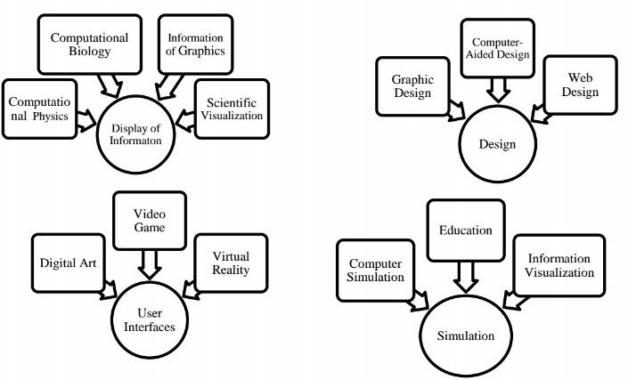

1. **Computational Biology:** Computational biology is a field that applies the techniques of computer science, applied mathematics and statistics to address biological problems. The main focus lies on developing mathematical modeling and computational simulation techniques.
2. **Computational Physics:** Computational physics is the study and implementation of numerical algorithm to solve problems in physics for which a quantitative theory already exists.
3. **Information of Graphics:** Information graphics are visual representations of information, data or knowledge. These graphics are used where complex information needs to be explained quickly and clearly, such as in signs, maps, journalism, technical writing, and education.
4. **Scientific Visualization:** Scientific visualization focuses on the use of computer graphics to create visual images which aid in understanding of complex, often massive numerical representation of scientific concepts or results.
5. **Graphic Design:** Graphic design can refer to a number of artistic and professional disciplines which focus on visual communication and presentation. Various tools like Coral Draw, In Design, photo shop are used.
6. **Computer-aided Design:** Computer-aided design (CAD) is the use of computer technology for the design of objects, real or virtual. CAD is also widely used to produce computer animation for special effects in movies, advertising, technical manuals.
7. **Web Design:** The process of designing Web pages, Web sites, Web applications or multimedia for the Web may utilize multiple disciplines, such as animation, communication design, corporate identity, graphic design, interaction design, marketing, photography, search engine optimization etc.
8. **Digital Art:** The impact of digital technology has transformed traditional activities such as painting and drawing.
9. **Video Games:** A video game is an electronic game that involves interaction with a user interface to generate visual feedback on a raster display device. The electronic systems used to play video games are known as platforms. This platform creates through graphics.
10. **Virtual Reality:** Virtual reality (VR) is a technology which allows a user to interact with a computer-simulated environment. The simulated environment can be similar to the real world, for example, simulations for pilot or combat training, or it can differ significantly from reality, as in VR games.
11. **Computer Simulation:** A computer simulation, a computer model or a computational model is a computer program, or network of computers, that attempts to simulate an abstract model of a particular system.
12. **Education:** Different computer graphics and images are used in schools and many training center for the better understanding the subject of interest.
13. **Information Visualization:** Information visualization is the study of the visual representation and the use of graphical techniques to help people understand and analyze data